Usage Manual for ‘The Bookworm Shack’

TEAM 10

Jeet Agnihotri

Bhavya Sen

Github Repository: <https://github.com/bhavyasen/ecommerce>

**INTRODUCTION**

‘The Bookworm Shack’ is a website to buy different genre of books. Users can order books and chat with other users too.

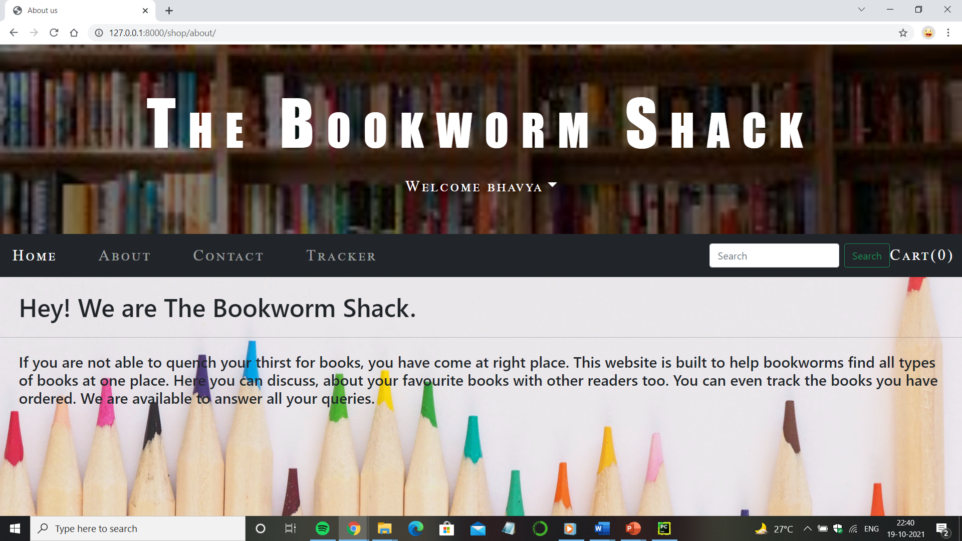

**Features of website:**

* Products on website can be searched using search button.
* Multiple books can be added to shopping cart.
* Books can be ordered through ‘checkout’ feature.
* Orders can be tracked using tracker feature.
* A user can discuss about books with other users using chat feature.
* Users can send their grievance to us through contact details provided.

**Goal** of website is to offer a one stop solution to book lovers.

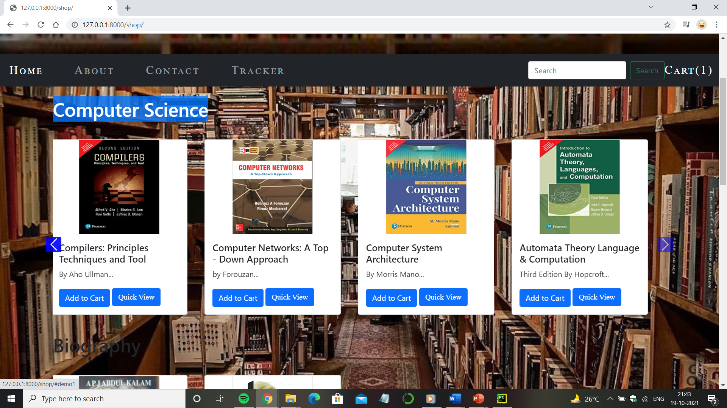

Page to view books

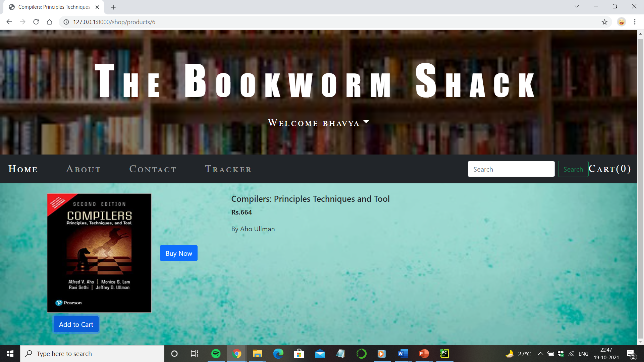

Page for ordering books

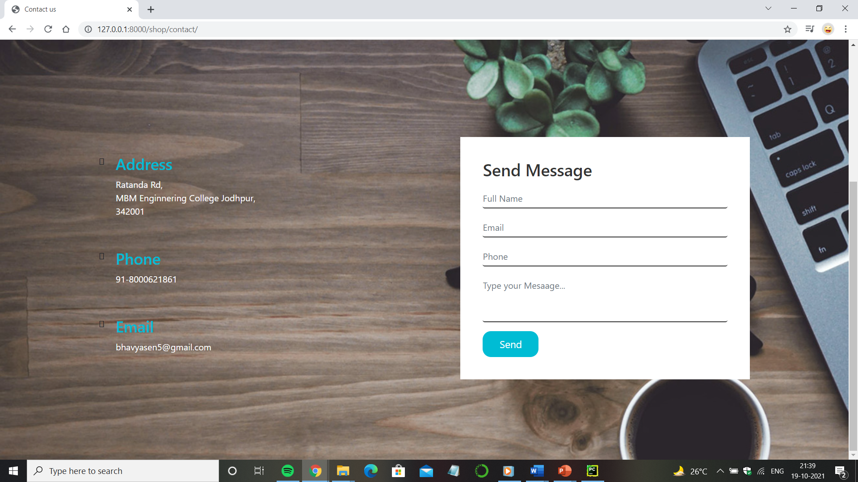

Page to contact admin

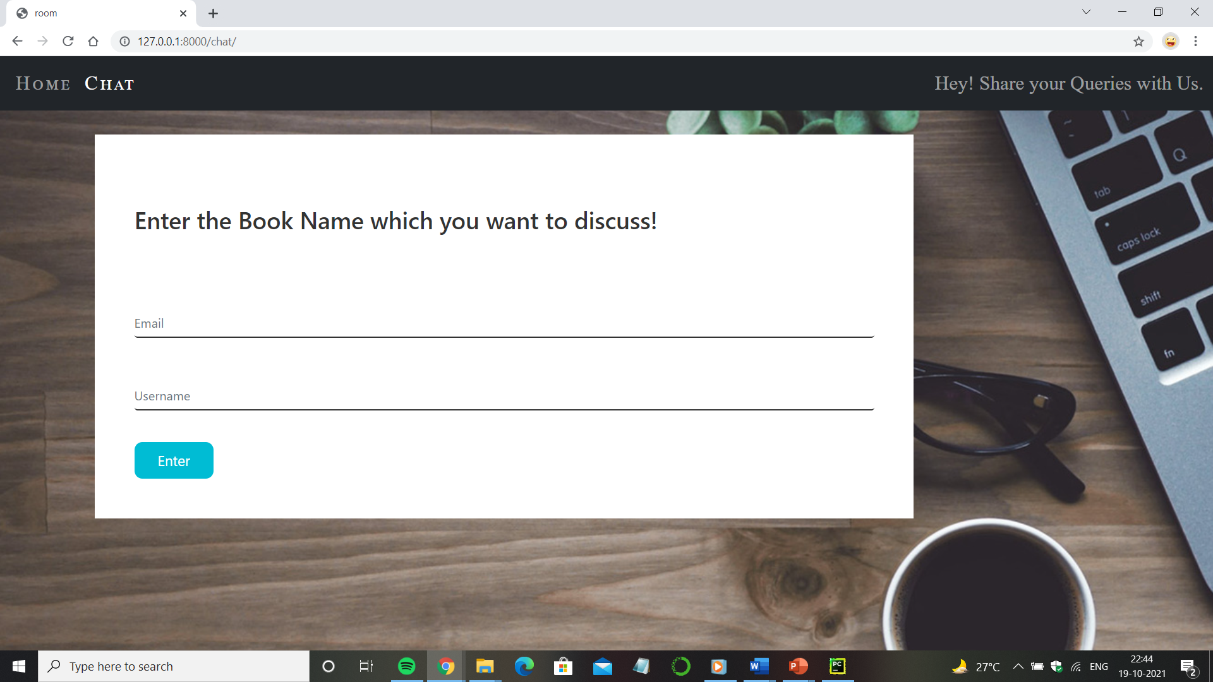

Page to chat with other users